Meter Table
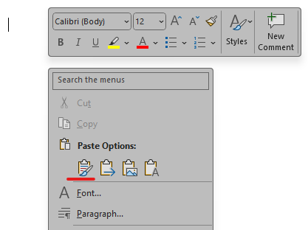
Please copy the table using the table’s right-click menu > Copy and paste the table into an empty line using source formatting for the best results.
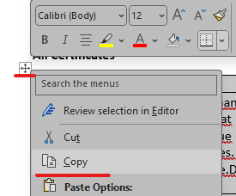

All Meters
Meter | Opening Reading | Closing Reading | Serial Number | Location
[[Meter.Name]] | [[Meter.OpeningReading]] | [[Meter.ClosingReading]] | [[Meter.SerialNumber]] | [[Meter.Location]]

