Certificate Tables
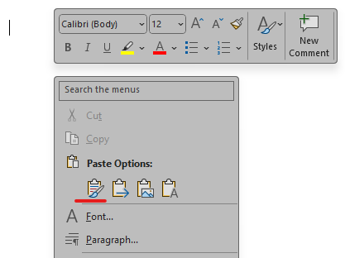
Please copy the table(s) using the table’s right-click menu > Copy and paste the table(s) into an empty line using source formatting for the best results.
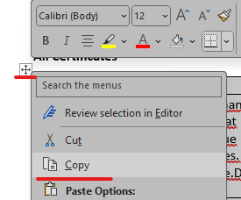
All Certificates
Certificate | Due Date | Responsibility | Description
[[MaintenanceCertificates.OverdueCertificates.Certificate.Type]] | [[MaintenanceCertificates.OverdueCertificates.Certificate.Due]] | [[MaintenanceCertificates.OverdueCertificates.Certificate.Responsibility]] | [[MaintenanceCertificates.OverdueCertificates.Certificate.Description]]
[[MaintenanceCertificates.ValidCertificates.Certificate.Type]] | [[MaintenanceCertificates.ValidCertificates.Certificate.Due]] | [[MaintenanceCertificates.ValidCertificates.Certificate.Responsibility]] | [[MaintenanceCertificates.ValidCertificates.Certificate.Description]]

Only Overdue
Certificate | Due Date | Responsibility | Description
[[MaintenanceCertificates.OverdueCertificates.Certificate.Type]] | [[MaintenanceCertificates.OverdueCertificates.Certificate.Due]] | [[MaintenanceCertificates.OverdueCertificates.Certificate.Responsibility]] | [[MaintenanceCertificates.OverdueCertificates.Certificate.Description]]

Only Due
Certificate | Due Date | Responsibility | Description
[[MaintenanceCertificates.ValidCertificates.Certificate.Type]] | [[MaintenanceCertificates.ValidCertificates.Certificate.Due]] | [[MaintenanceCertificates.ValidCertificates.Certificate.Responsibility]] | [[MaintenanceCertificates.ValidCertificates.Certificate.Description]]

