Inventory Table
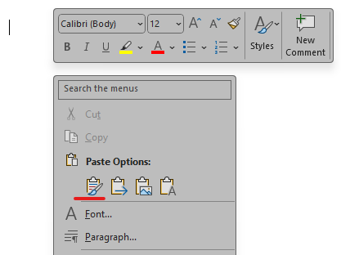
Please copy the table using the table’s right-click menu > Copy and paste the table into an empty line using source formatting for the best results.
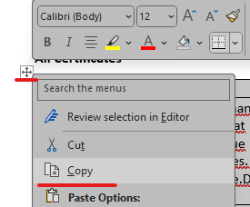

Inventory Table
Item | Quantity | Comment
[[PropertyStructure.InventoryItem.ItemType]] | [[PropertyStructure.InventoryItem.Quantity]] | [[PropertyStructure.InventoryItem.Comment]]

